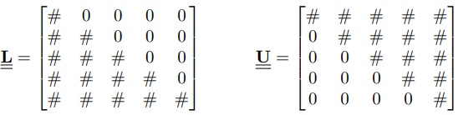

**Eigenvalue Problem**



**Coordinate transform:**

**Gauss-Jordan:**

**LU decomposition:**

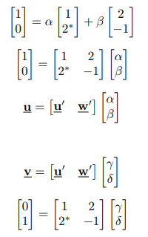



**Gerschgorin`s theorem**



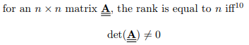

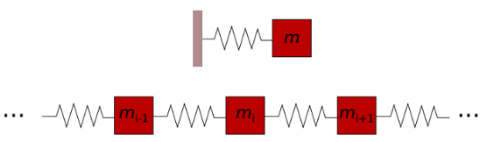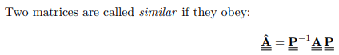



**Infinite solutions**

**No solutions**







**Lp Norm:**



**Matrix Norm:**

**QR Factorization**



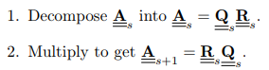



def powerMethod(A,x0,n):

x = x0

for i in range(0,n):

x = np.matmul(A, x)

a = np.max(x)

x = x/a

return x

**Power Method:**

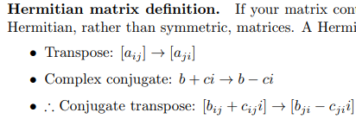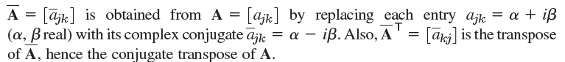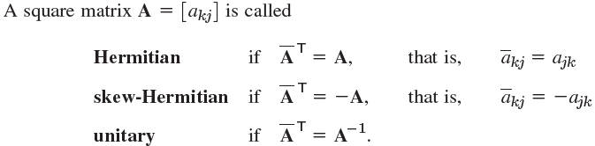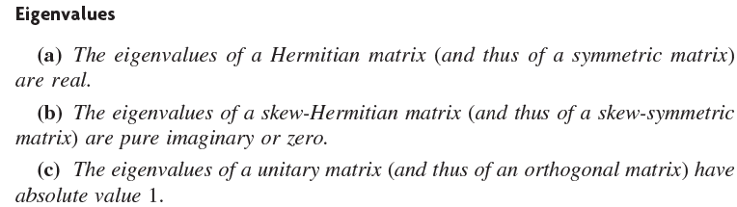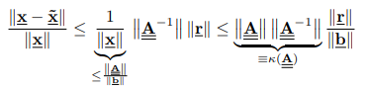

**Condition Number:**

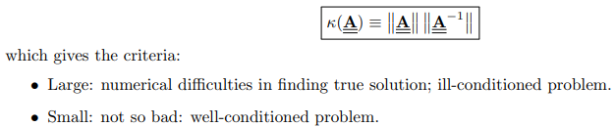

**Factor out roots:**

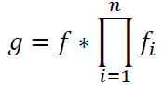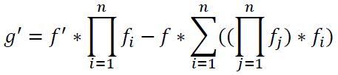

**Bifurcation:**



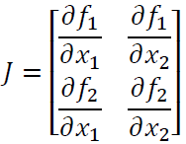



**Newton_Raphson Iteration:**

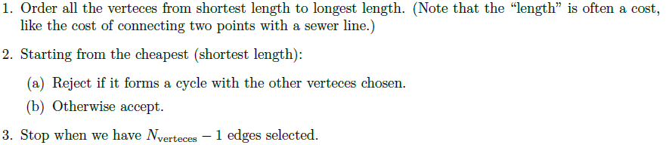

**Shortest Spanning Tree:**

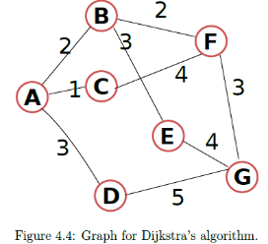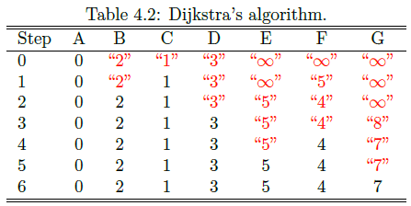

**Dijkstra:**

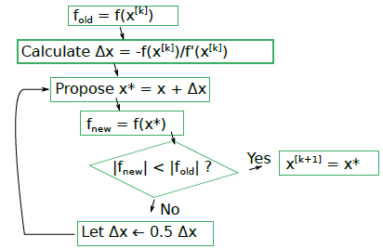

**Linesearch:**

**Prim:**

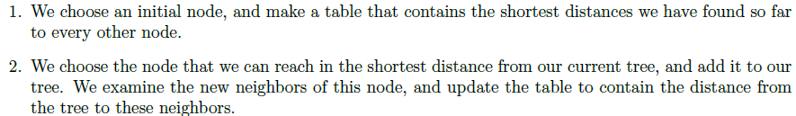



**Improved Euler:**



**Runge Kutta:**

**Explicit Euler:**



**Discretizing:**

